**Brain Tumor Detection Using Deep Learning**

**Detailed Report**

1. Introduction

Brain tumors are life-threatening abnormalities that require early detection. This project employs a Convolutional Neural Network (CNN) to classify MRI scans as tumor-positive or tumor-negative, utilizing deep learning techniques.

2. Dataset Description

Training Data: 5012 images (Balanced: 50% Tumor Positive, 50% Tumor Negative)

Validation Data: 420 images (Unseen Data)

Data Augmentation: Applied transformations such as zoom, rotation, and flipping to enhance data variability.

3. Model Architecture

A CNN model was designed with the following layers:

Convolutional Layers: 4 blocks with increasing filter sizes (64, 128, 256, 512)

Batch Normalization & Dropout: Regularization techniques applied to prevent overfitting.

Pooling Layers: MaxPooling layers used to reduce dimensionality.

Fully Connected Layers: Two dense layers (256 and 128 neurons)

Output Layer: Single neuron with sigmoid activation (Binary Classification)

4. Model Compilation and Training

Optimizer: Adam

Loss Function: Binary Crossentropy

Metrics: Accuracy

Callbacks Used:

ModelCheckpoint: Saves the best model per epoch

EarlyStopping: Stops training when no improvement is observed

ReduceLROnPlateau: Reduces learning rate on a performance plateau

Training Results:

| Epoch | Train Accuracy | Train Loss | Val Accuracy | Val Loss |
| --- | --- | --- | --- | --- |
| 1 | 95.77% | 0.1258 | 81.43% | 0.8684 |
| 2 | 96.61% | 0.1010 | 50.00% | 3.0553 |
| 3 | 96.43% | 0.0951 | 79.29% | 0.8238 |
| 4 | 96.50% | 0.0953 | 80.24% | 0.8639 |
| 5 | 97.35% | 0.0814 | 78.57% | 0.7821 |
| 6 | 97.01% | 0.0926 | 51.43% | 2.8400 |
| 7 | 97.93% | 0.0684 | 55.24% | 2.2704 |
| 8 | 97.22% | 0.0835 | 50.00% | 3.8948 |
| 9 | 98.23% | 0.0544 | 82.86% | 0.8557 |
| 10 | 98.03% | 0.0550 | 80.00% | 1.0946 |

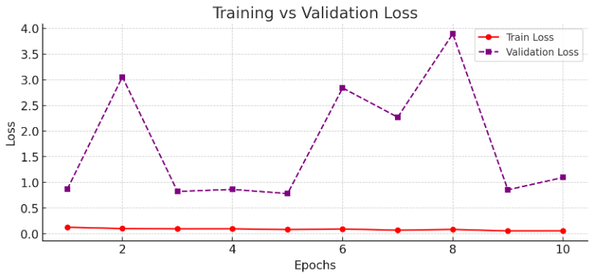

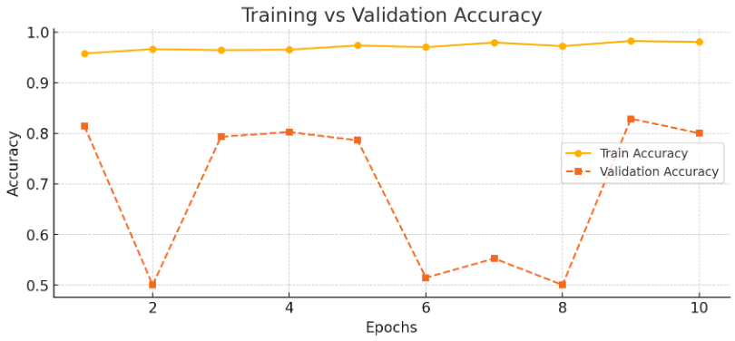

5. Model Evaluation

Confusion Matrix:

Tumor Negative: Precision = 0.75, Recall = 0.98, F1-score = 0.85

Tumor Positive: Precision = 0.97, Recall = 0.68, F1-score = 0.80

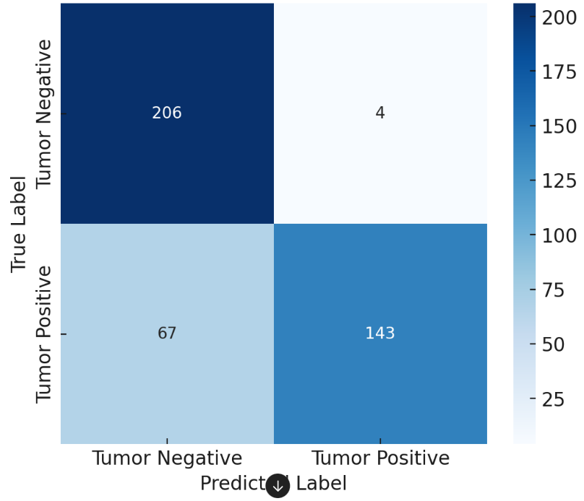Overall Accuracy: 82.86%

6. Deployment Using Flask

After training the model on Google Colab, the best-performing model was saved and downloaded to a local computer. A Flask-based web server was implemented to integrate the model with a user-friendly interface, allowing users to upload MRI images for real-time tumor predictions.

7. Conclusion and Future Work

The CNN model achieves an accuracy of 82.86%, showing strong precision but slightly lower recall for Tumor Positive cases. Future improvements may include:

Using transfer learning with pre-trained models (e.g., ResNet, VGG)

Experimenting with different hyperparameters and augmentation techniques

Collecting more diverse data to improve generalization

This model provides a foundation for automated brain tumor detection, assisting radiologists in diagnosing patients efficiently.